LAB REPORT-02

# Course Code: CSE-456

# Course Title: Multimedia and Animation technique laboratory

# Submitted To:

Dr. Mohammad Zahidur Rahman

Professor

Jahangirnagar University

# Submitted By:

|  |  |  |
| --- | --- | --- |
| Roll | Name | Role |
| 04 | Jannatul Ferdous | Art director |
| 06 | Mahmuda Naznin Eva | Designer |
| 11 | Rehnuma Reza Deepty | Content Expert |
| 15 | Albina Alam | Team Leader |
| 1719 | Hasin Arman Sifat | Educational Technologist |

E-content on Engineering Drawing

**Experiment Name :** Educational and Design Criteria for e-content . Develop a multimedia based interface for e-content for BSc(Hons) 1st year 1st semester(Engineering Drawing) by each team consisting of 5 members playing all the expert roles..

1. **Determining the educational goals of the course , general goal, partial goal ,topic explanation.**

**Topic Explanation:**

Our e-content is based on Engineering Drawing .Engineering drawing referred to as engineering graphics, is the art of manipulation of designs of a variety of components, especially those related to engineering. It primarily consists of sketching the actual component, for example a machine, with its exact dimensions. The scale of dimensions is suitably adjusted so as to properly fit within the contours of the drawing sheet.

Various aspects regarding to any hardware architectural design implementation can be achieved though engineering drawing.

**Educational Goal :**

Educational goal of the content is to convey all the required information that will allow the manufacturer to produce that component

**General Goal :**

General goal of the content is To fully and clearly define requirements for engineered items and usually to create in accordance with standarized conventions for layout, nomenclature ,interpretation , appearance size etc.

**Partial Goal:**

Partial purpose is to accurately and unambiguously capture all the geomatric features of a product or components.

1. **Determining the coverage and flow required to accomplish the educational goal.**

Our e-content is motivated to cover all the topics regarding to engineering drawing given below:

* Line drawing
* Introduction to types of lines
* Lettering
* Free hand drawing
* Geometric construction
* Projection
* Perception

The order how the topics will be covered is given below:

Introduction to tools required for drawing

Learning to draw different types lines

Learning to lettering

Dimensioning

Projection

Perspective

1. **Determining the evaluation scales:**

Evaluation scales is usually measured through the factors given below:

* **Response :**

The goal of the E-content will be fulfilled if the response from the users towards the E-content is positive or tends to positive.

* **Efficiency :**

All the contents are perfectly oriented visually and graphically and the materials are more responsive from the user perspection.

* **Simplicity of Design:**

E-content must be attractive ,unambiguous and free of redundancy visually to the users.

* **Time evaluation:**

Each contents of the system will not too much tedious and is to be delivered within the expected schedule time.

* **Compatibility and portability:**

The system should run on as much various platforms as it can. So, more user can make use of it.

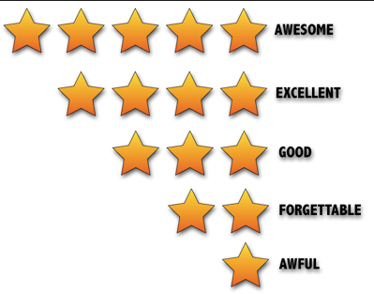

Since we are in the preliminary stage of this project,it is not completed yet.We will try to cover all the evaluation factors described above .After the completion we will provide an evaluation along with the product where the student will give feedback through rating the product.For example,the student will rate 5 stars if the contents of the system fulfills his 90% expectation, 4stars if it fulfills his 70% satisfaction and 3stars otherwise.

1. **Producing the materials to be used in the contents.**

The materials to be added to the e-content are given below-

* **Text:**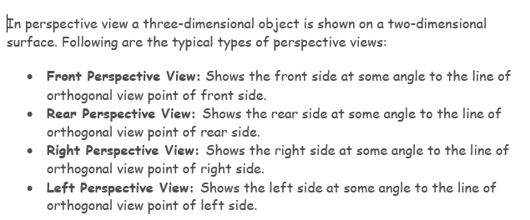
* **Graphics :** This graphic is for different view of perspective view ,

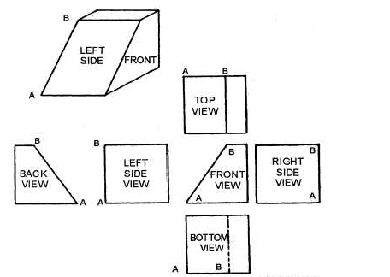

* **Animation :**

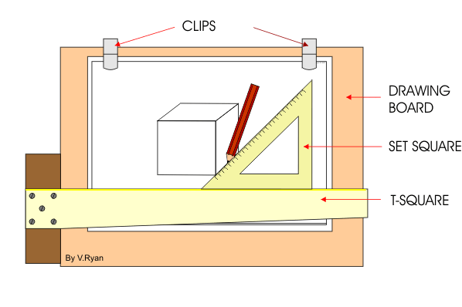

* **Audio :**



* **Video :**

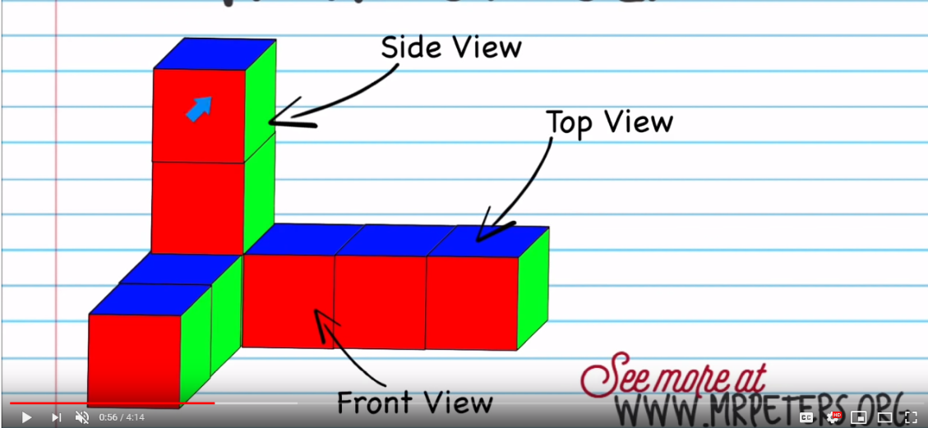

1. **Building the materials in order to produce educational result:**

Using the materials described above,we will provide -

* video tutorials,
* quiz system,
* summary,
* overviews etc.

1. **Making changes according to the feedback on a trial version of the e-content:**

Our project plan is to build a system prototypes and provide them to the expert users for their overviews or feedbacks over the product , so that they can propose some required changes. After evaluation of these feedbacks , we can introduce revised versions, that can earn more acceptance of the project.